Required Assignment 27:
Deploying Efficient Deep Learning Systems
<Yeo Keng Chuan>
 | Estimated time: 90 minutes

Scenario:
A global retail company plans to deploy an AI-powered product recognition system that identifies products from images uploaded through a mobile application. While the current deep learning model achieves excellent accuracy, it is too large for efficient deployment, resulting in high memory consumption, slow inference time and increased deployment costs.
As the company's AI engineer, you have been asked to evaluate alternative deep learning approaches and recommend a deployment-ready solution that balances model performance with computational efficiency.

Task 1:
Compare two deep learning architectures (e.g., ResNet and Inception) by discussing:
- their key design features
- strengths and limitations
- suitable real-world applications
Write your response here:

Task 1 Compare two neural network architectures
I compare two deep feedforward multilayer perceptrons rather than image CNNs. Iris contains four tabular measurements, so ResNet or Inception would require an image dataset and a different problem definition. Both networks use two ReLU hidden layers and a three-class softmax output.
Feature | Larger MLP | Compact MLP
Layer widths | 4 → 64 → 32 → 3 | 4 → 16 → 8 → 3
Trainable parameters | 2499 | 243
Strengths | More capacity for nonlinear relationships | Fewer parameters and less computation
Limitations | Overfitting risk on a small dataset; larger storage | May underfit more complex datasets
Application | Baseline for comparing accuracy and capacity | Offline classification of measured Iris flowers
Standardisation is fitted only on 90 training samples. Thirty validation samples support model selection; another 30 samples are reserved for one final test. Both splits are stratified using random seed 42. Row identifiers are not features. The model cannot identify arbitrary plants or classify photographs.

Paste screenshot(s) supporting your answer below:

Task 2:
Recommend one model optimisation technique (e.g., pruning, knowledge distillation or quantisation) that would improve deployment efficiency.
- Explain how the technique works
- Discuss its impact on model size, inference speed and accuracy
- Justify why it is appropriate for the retail mobile application
Write your response here:

Task 2 Recommend model optimisation
I recommend post-training symmetric 8-bit weight quantisation of the compact network to reduce parameter storage. Each matrix uses scale s = max(abs(W)) / 127. The stored weights are q = clip(round(W / s), −127, 127), represented as int8. Inference approximates W using q × s. Biases, scales and standardisation remain floating point. This is weight-only quantisation.
A float64 weight occupies eight bytes and an int8 weight one byte, before scale overhead. The entire saved file shrinks less because it includes preprocessing, biases, class labels, metadata and runtime code. Rounding may affect predictions, so accuracy and macro F1 must be measured after conversion.

Measured validation comparison
Model | Accuracy | Macro F1 | File bytes | p50 ms | p95 ms
large_mlp | 0.9667 | 0.9666 | 24092 | 0.01975 | 0.02378
compact_mlp | 0.9667 | 0.9666 | 6044 | 0.01365 | 0.01410
compact_int8 | 0.9667 | 0.9666 | 4568 | 0.01643 | 0.01710
The quantised compact file is 24.4% smaller than the compact floating point file and 81.0% smaller than the larger baseline. Validation accuracy is unchanged at 29/30 correct. File sizes use cloudpickle with the same wrapper for all three candidates.
Latency was measured for one flower, after 30 warm-up calls and over 500 predictions, using the same NumPy runtime wrapper. Quantisation is slower than the compact floating point network here because weights are reconstructed during inference. An optimised integer runtime may improve speed on supported hardware, but that benefit is not demonstrated by this implementation. The Python runtime and package footprint are excluded from the model-file sizes.
The technique suits a storage-constrained offline field application because it reduces the saved model and update payload without reducing validation accuracy in this experiment. Offline inference needs no Wi-Fi once the software and model are installed. Energy, total device RAM and financial savings have not been measured.

Paste screenshot(s) supporting your answer below:

Task 3:
Explain how MLflow can support the deployment process by describing how it can be used to:
- Track experiments
- Compare model performance
- Manage model versions
- Improve reproducibility during deployment
Write your response here:

Task 3 Explain how MLflow supports deployment

Track experiments
One run per candidate records layer widths, quantisation type, random seed, split sizes and training settings. Metrics include validation accuracy, macro F1, serialized size, parameter count and single-flower latency. Training time is logged for the two trained floating point networks.

Compare performance
All candidates share the same dataset, split and feature processing. The notebook queries only the runs created during the current execution and prints their parameters and metrics. The selection rule ranks validation accuracy first, then file size and p95 latency. Test results are not used for choosing the candidate.

Manage model versions
Each logged model is registered under IrisNeuralDeployment. The current execution creates versions 1, 2 and 3. The candidate alias points to version 3, compact_int8. Code uses the version returned by registration rather than a hard-coded run ID. A fixed version URI reloads the selected model for verification; retaining older versions supports rollback.

Improve reproducibility
Each run stores the dataset, its SHA256 fingerprint, exact split indices, feature schema, class mapping and software-version tags. The MLflow model includes an input signature, input example and pinned inference dependencies. The scaler is bundled with the inference model to prevent training and deployment preprocessing differences.

Execution evidence
Model | Registered version | Run ID
large_mlp | 1 | 6f3f9710f7f94d65bc37b36885fc2fbc
compact_mlp | 2 | 49f8a6c287c545fbb90e44cf1a23b2b6
compact_int8 | 3 | 023577cf0bae48beadfac4b353e7e972
The notebook includes executed outputs for parameter counts, comparison metrics, run IDs, registry versions and offline inference. MLflow reloading and offline reloading both produced exactly the same test predictions as the selected in-memory runtime.

Paste screenshot(s) supporting your answer below:

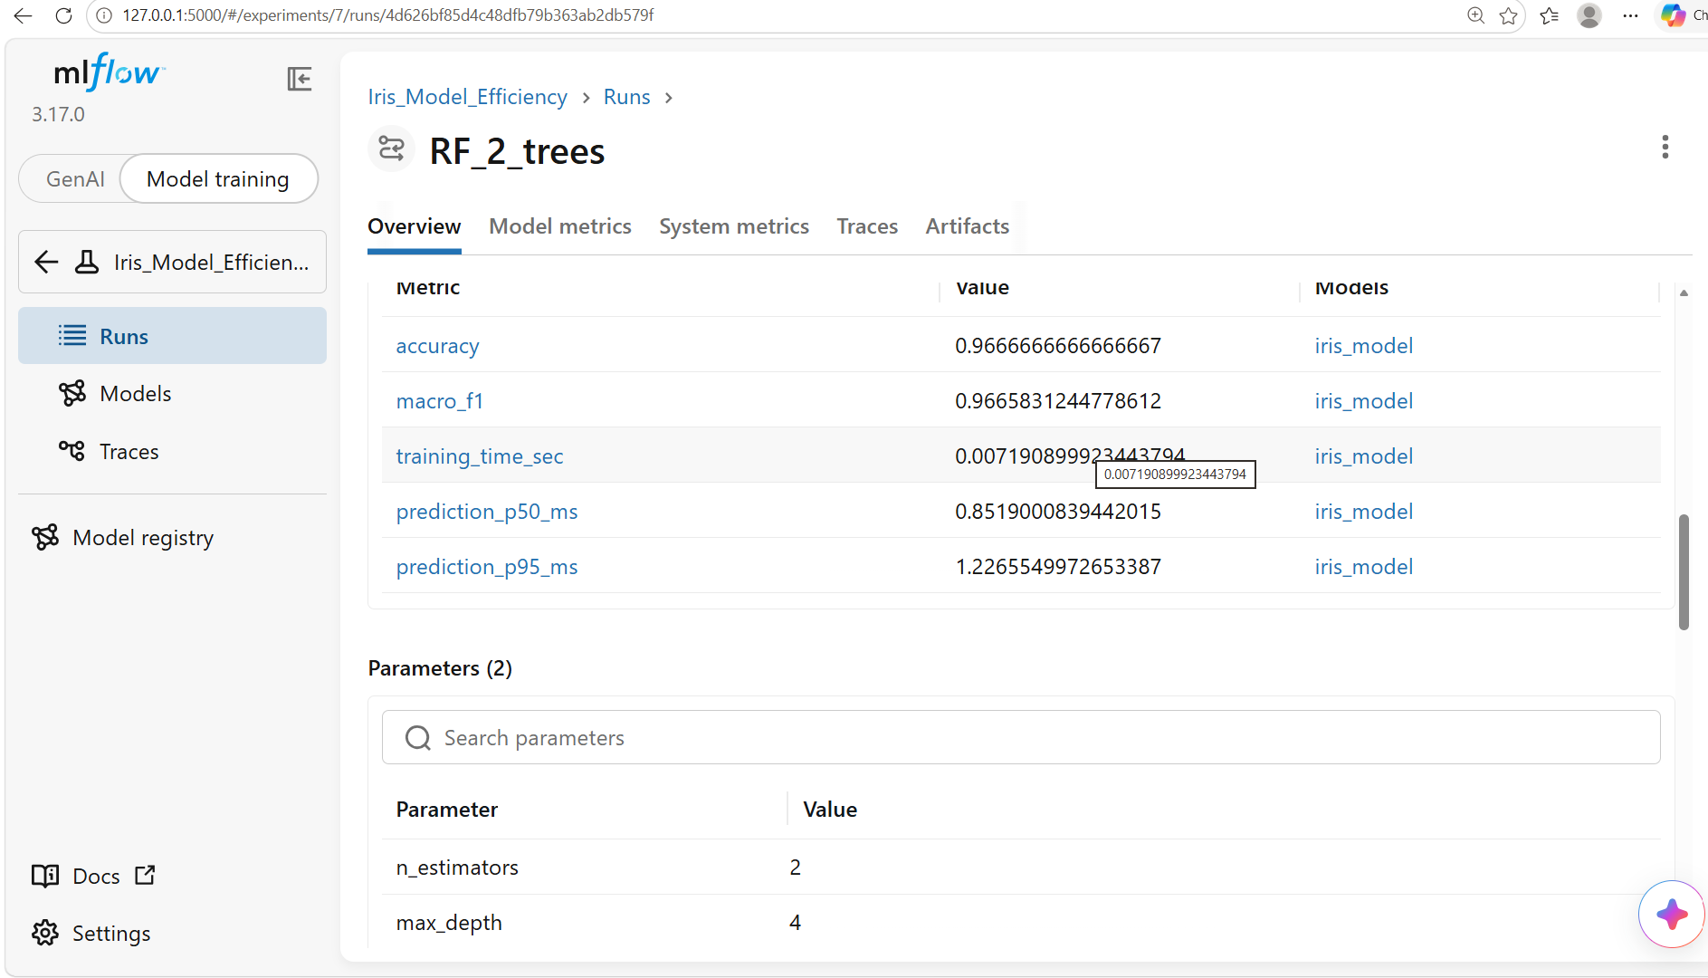

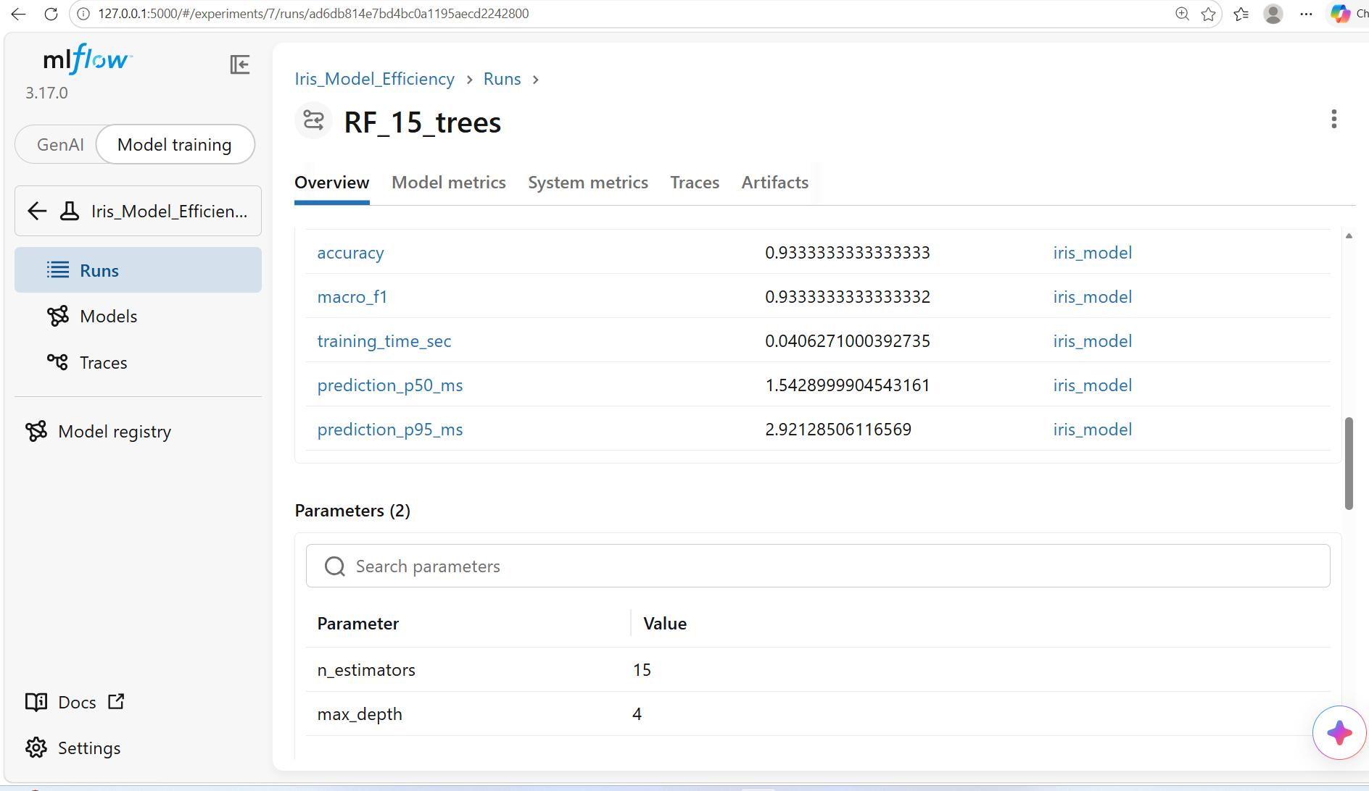

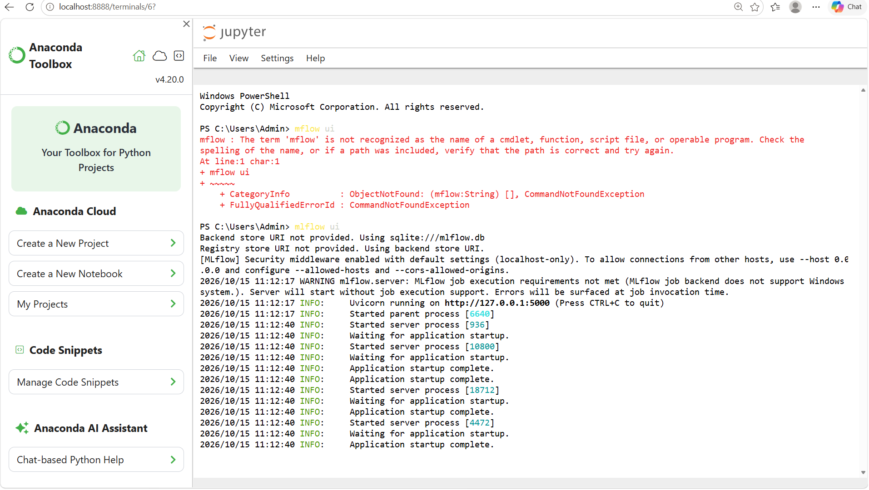

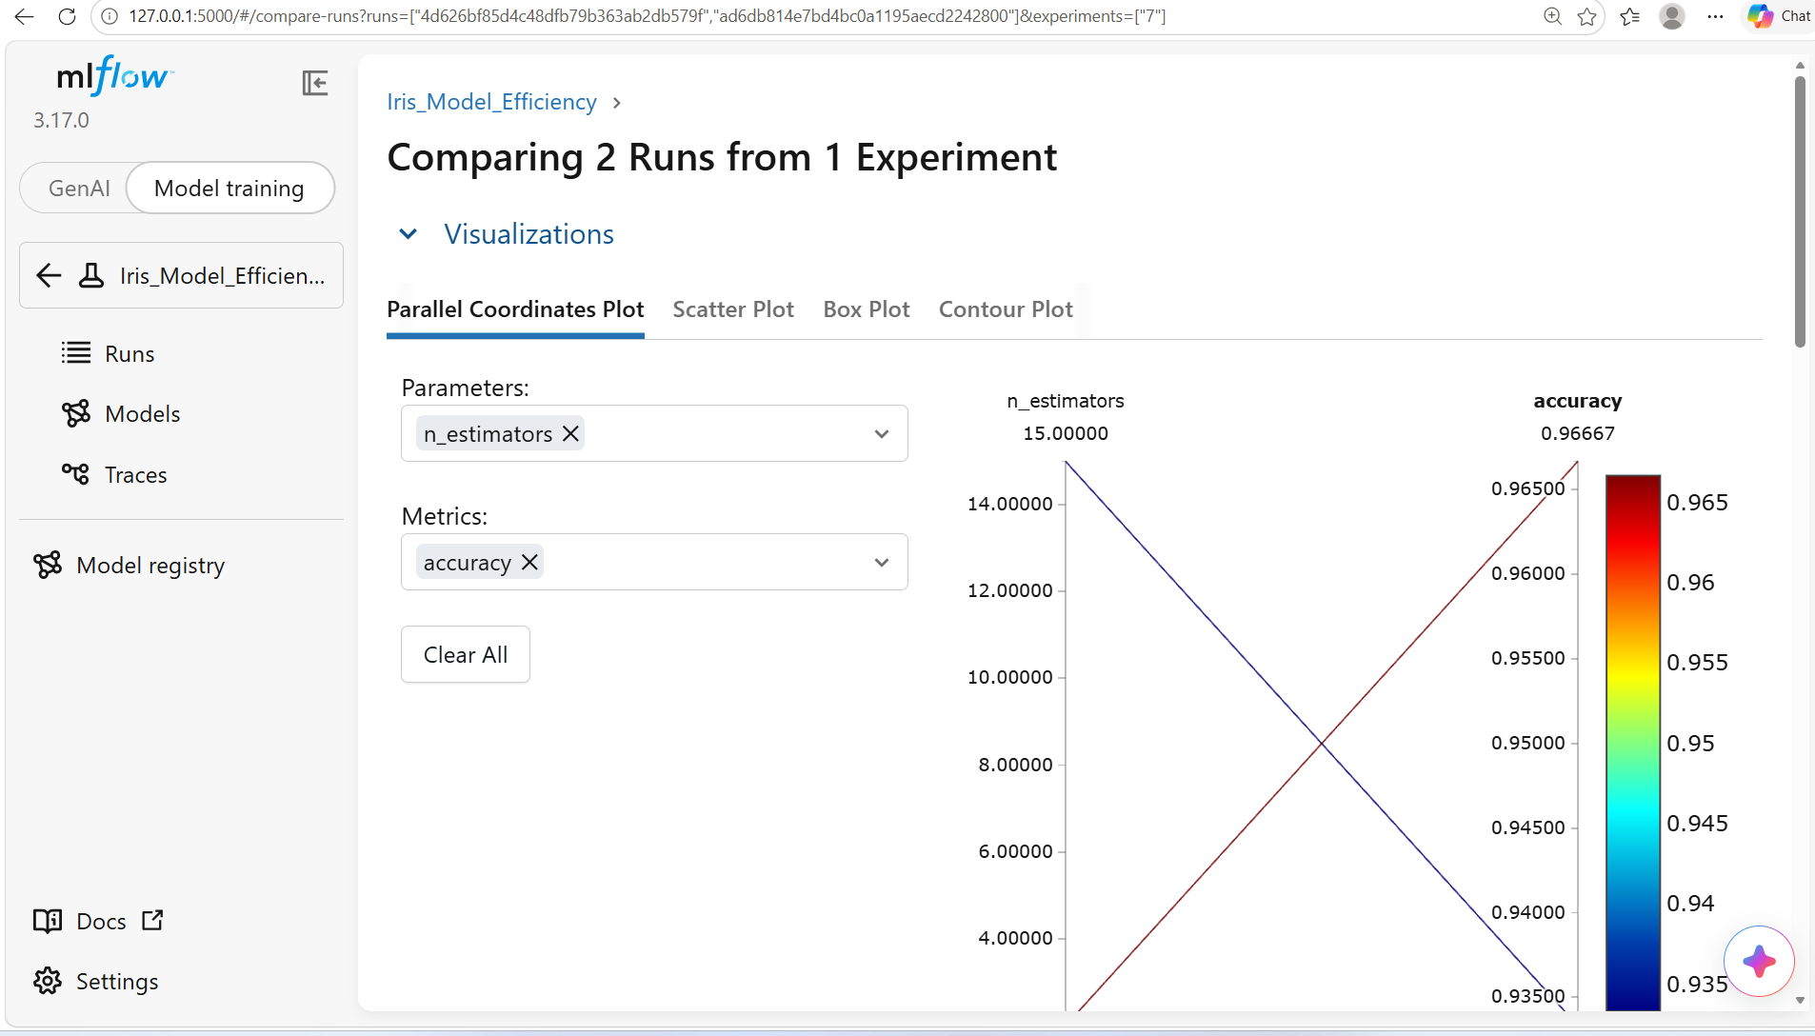
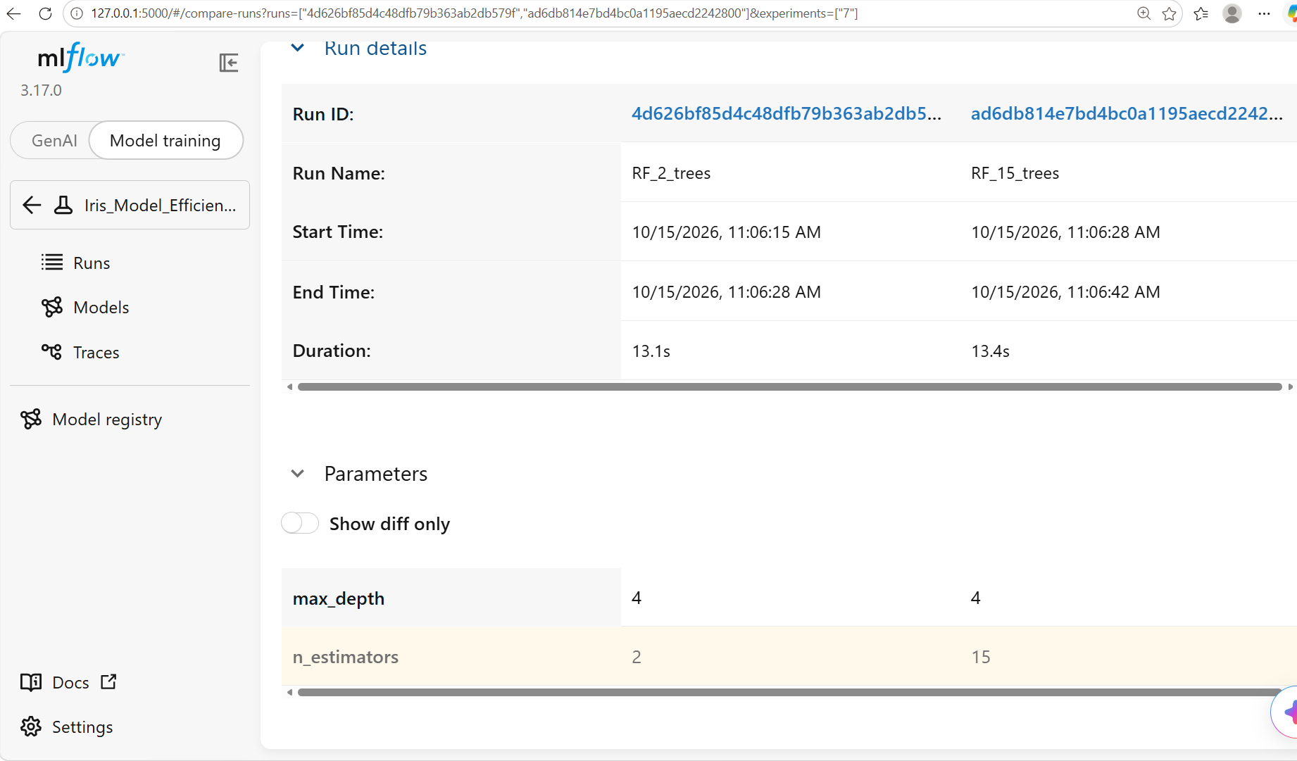
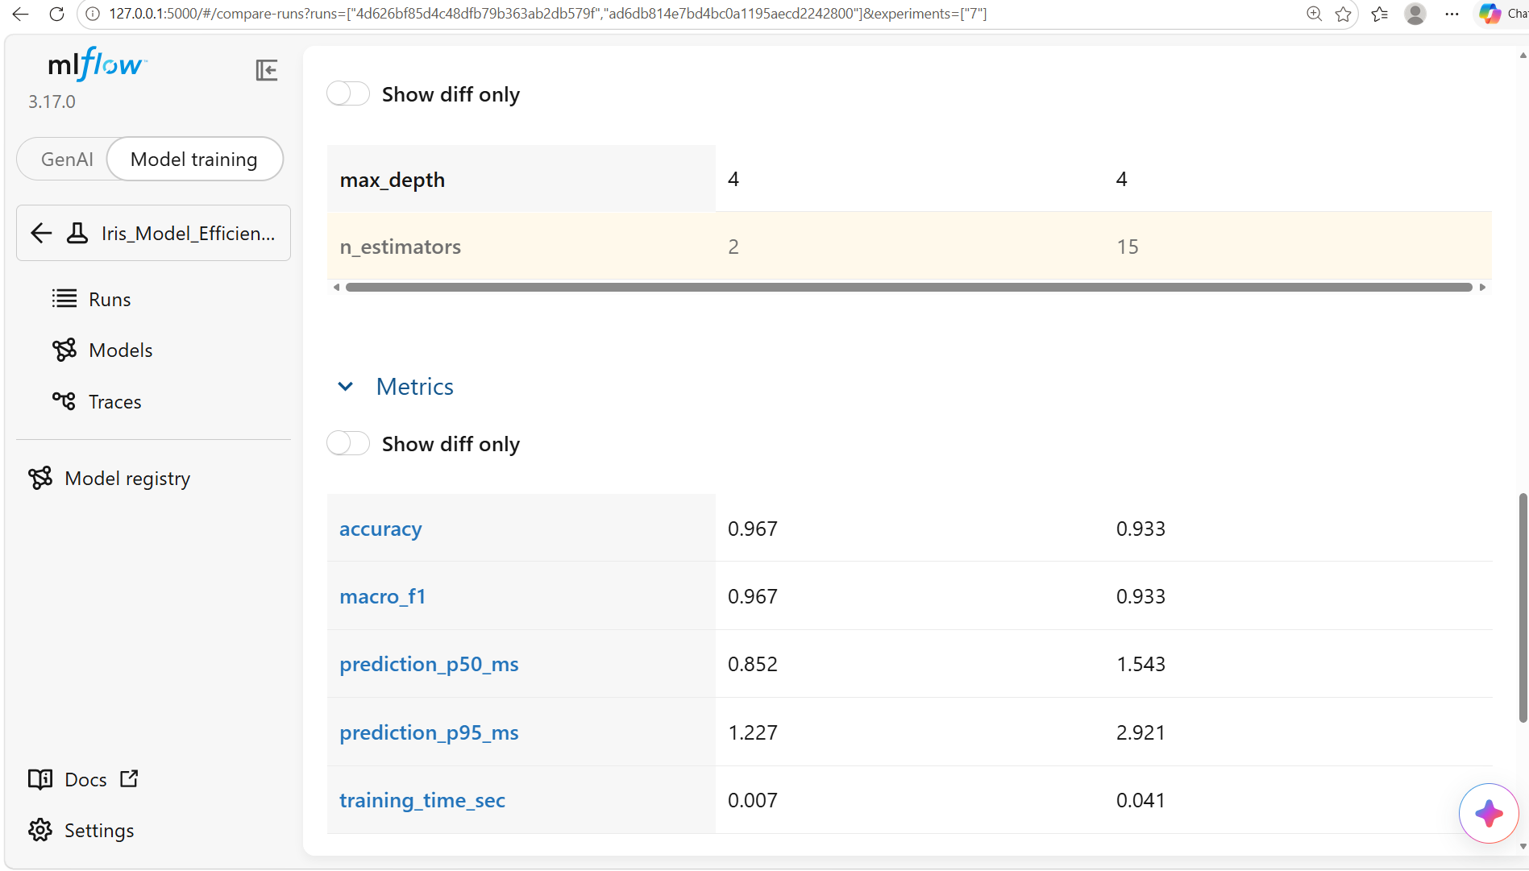

Task 4:
Recommend the final deployment-ready solution, explaining how your selected architecture, optimisation technique and MLflow together address the company's deployment challenges.
Write your response here:

Task 4 Recommend the final solution
I select the quantised compact MLP, with layer widths 4 → 16 → 8 → 3, for this storage-focused prototype. All candidates achieved the same validation accuracy, so the stated ranking selected the smallest serialized file. If latency is the primary device constraint, the compact floating point network is the preferable candidate based on these measurements.
The selected network contains 243 parameters and its saved comparison artifact is 4568 bytes. It achieved 96.67% validation accuracy and 90.00% accuracy on the untouched test set, with test macro F1 of 0.8977. This equals 27/30 correct test predictions. The sample [5.1, 3.5, 1.4, 0.2] was predicted as Iris-setosa. The final portable deployment file includes runtime code and may differ in size from the comparison artifact.
The compact architecture reduces the number of parameters; quantisation further reduces weight storage. MLflow connects the chosen model to its training configuration, evaluation evidence and registered version. Together these support a smaller offline package and controlled updates. They do not establish a reduction in device energy use or operating costs.

Deployment procedure
- Package the selected model with its fitted scaler, feature names, centimetre units, class mapping and pinned inference dependencies. Load only trusted model files.
- Provide a form for the four flower measurements. Reject missing or nonnumeric inputs and route unsupported species or unfamiliar conditions for expert review.
- Run acceptance tests on the intended device for latency, memory, accuracy and power use. Retain the floating point model if integer conversion does not satisfy the device requirements.
- After acceptance, record the released version in MLflow and retain the previous version for rollback. Deliver updates when connectivity is available; predictions remain local.
Limitations: only three species and 150 observations were studied. A single test set of 30 flowers has substantial uncertainty. Before operational deployment, obtain independently collected field data, check measurement variability and unsupported inputs, and define acceptance criteria with the application owner. This is deployment-ready code for a demonstration, not evidence of field readiness.

Paste screenshot(s) supporting your answer below:

Jupyter Notebook Submission
Paste the shareable link to your completed Jupyter Notebook below.
Notebook Link:
____________________________________________________________
Requirements:
- Ensure the notebook link is readily accessible.
- Set the sharing permission to 'Anyone with the link can view' (or equivalent).
- Verify that the notebook opens without requiring additional permission requests.
- The notebook should contain your code and outputs

MLflow Evidence
Paste screenshots of your MLflow experiment dashboard or logs below. Include, where possible:
- Model parameters
- Evaluation metrics
- Experiment comparison
- Model registration/versioning

Comments:
We are using the Iris set example provided because only the Iris set example are provided. No data set provided for Global retail.
I also provided 2 Notebook using different model for comparison.
The two notebooks use different models and different data splits, so they are not running the same experiment. I checked both files.
Setting | Iris_Assignment27(1).ipynb | MLFlow-1KC-3(1).ipynb
Model | Neural network (MLPClassifier) | Random forest (RandomForestClassifier)
Main settings | Hidden layers (64,32) or (16,8) | n_estimators=2 or 15; max_depth=3 or 4
Training data | 90 flowers | 120 flowers
Evaluation data | 30 validation + 30 separate test flowers | 30 test/validation flowers
Preprocessing | StandardScaler | No scaling
Quantisation | Includes an INT8 weight version | No quantisation
n_estimators and max_depth apply only to the random forest. The assignment notebook does not use those hyperparameters.
The assignment notebook’s saved results show:
- Validation accuracy: 96.67% — 29/30 correct.
- Selected model’s separate test accuracy: 90% — 27/30 correct.
Those scores use different flowers, so they can differ even for the same trained model.
There is also a difference within the MLFlow notebook: its first experiments omit stratify=y, while later experiments include it:
train_test_split( X, y, test_size=0.2, random_state=42, stratify=y)
Adding stratify=y changes which flowers enter the training and evaluation sets, even with random_state=42. When I reproduced its bundled Iris experiments using 15 trees and depth 4, I obtained:
Split | Accuracy
Without stratify=y | 100%
With stratify=y | 93.33%
These are my reproduced results; the MLFlow notebook has no saved accuracy outputs.
For a fair comparison, use the same dataset, exact training/evaluation rows, model type, preprocessing, and all model settings. Matching only the tree count and depth is insufficient.

